Sam McDowell

7/3/2020

Homework 4.1C

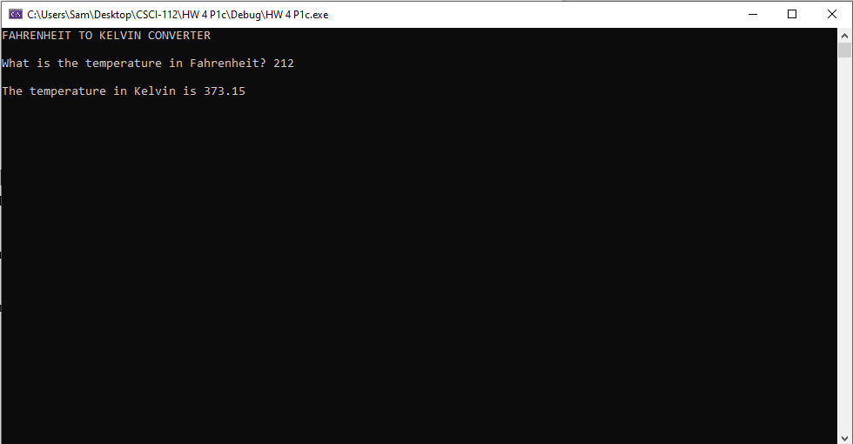

# Transcription:

FAHRENHEIT TO KELVIN CONVERTER

What is the temperature in Fahrenheit? 212

The temperature in Kelvin is 373.15